Day5: Azure virtual network:

A Virtual Network (VNet) in Azure is a logically isolated network that securely connects Azure resources and extends on-premises networks. Key features include:

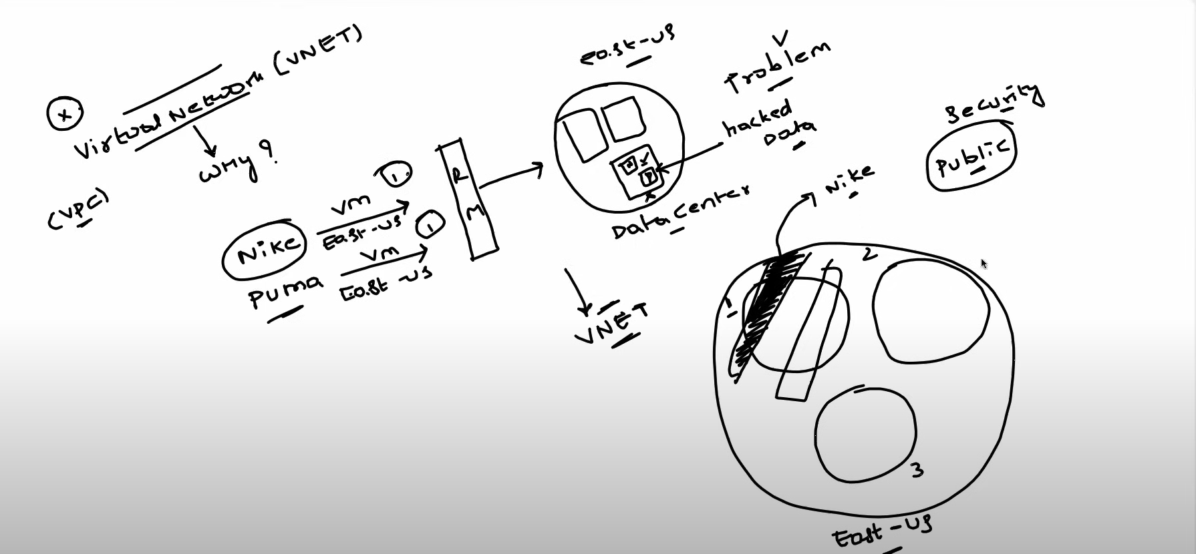

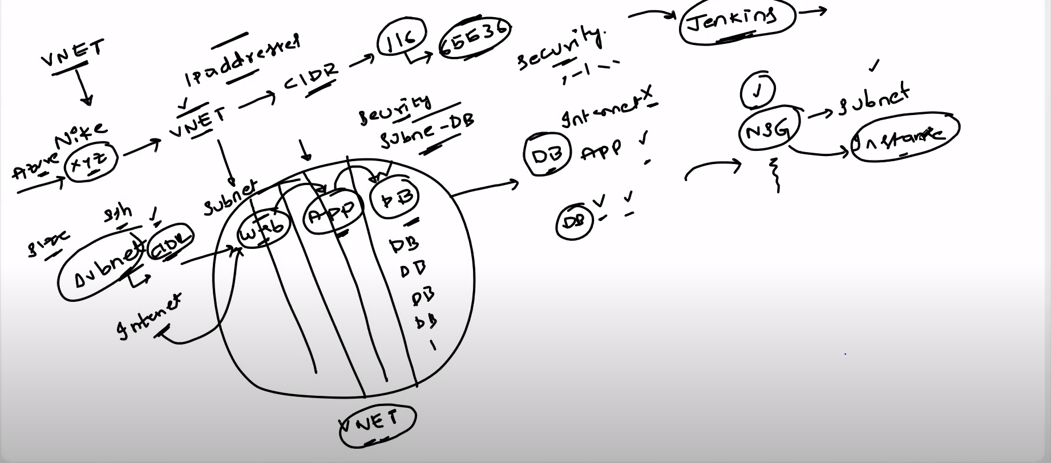

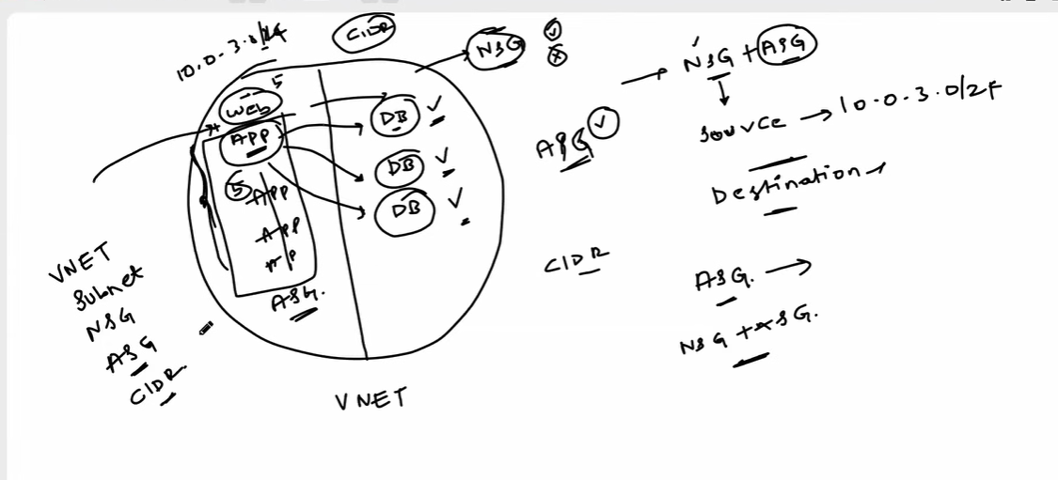

So when a request comes from the internet to web application , the request goes to business logic application and it fetches the data from database. Database is not accessible via internet. It can only be accessed by business logic application. So to define who can access what, there is network security group(NSG) where we can define and block the access.

**Network Security Groups (NSGs)**

NSGs are fundamental for Azure's network security, allowing filtering of inbound and outbound traffic. Key aspects include:

* **Rules**: NSGs define allowed or denied traffic based on source, destination, port, and protocol.
* **Default Rules**: NSGs have default rules for controlling traffic within the Virtual Network and between subnets.
* **Association**: NSGs can be associated with subnets or individual network interfaces.

## Application Security Groups (ASGs)

ASGs group Azure virtual machines based on application requirements, simplifying network security:

* **Simplification**: ASGs allow defining rules based on application roles instead of individual IP addresses.
* **Dynamic Membership**: ASGs support dynamic membership based on tags or other attributes.
* **Rule Association**: Security rules can be associated with ASGs for intuitive and scalable network security management.

## Subnets, CIDR

### Subnets

Subnets are subdivisions of a Virtual Network, allowing for better organization and traffic management.

### CIDR (Classless Inter-Domain Routing)

CIDR notation represents IP addresses and their routing prefix, specifying the range of IP addresses for a network.

## Routes and Route Tables

### Routes

Routes dictate how network traffic is directed, specifying the destination and next hop.

### Route Tables

Route Tables are collections of routes associated with subnets, enabling custom routing rules.

# Azure Networking Basic to Advanced

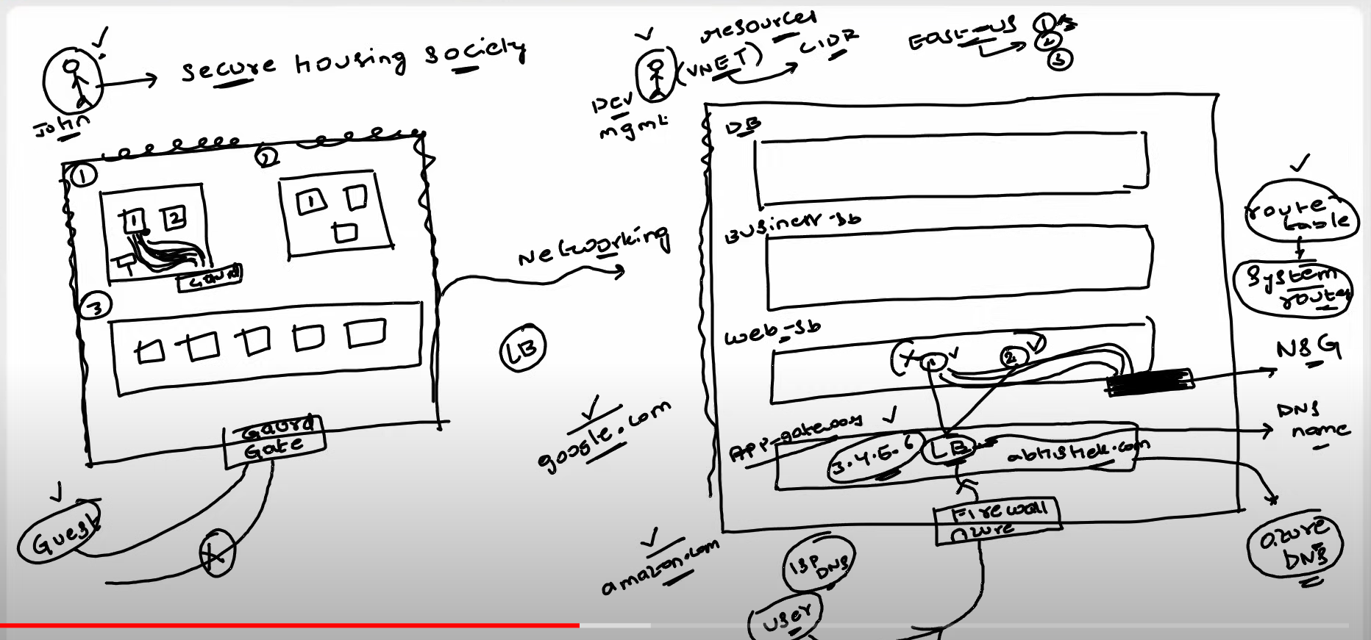

## Azure App Gateway & WAF

Azure Application Gateway is a web traffic load balancer that enables you to manage and route traffic to your web applications. Web Application Firewall (WAF) provides protection against web vulnerabilities. Key features include:

* **Load Balancing**: Distributes incoming traffic across multiple servers to ensure no single server is overwhelmed.
* **SSL Termination**: Offloads SSL processing, improving the efficiency of web servers.
* **Web Application Firewall (WAF)**: Protects web applications from common web vulnerabilities and exploits.

## Azure Load Balancer

Azure Load Balancer distributes incoming network traffic across multiple servers to ensure no single server is overwhelmed. Key features include:

* **Load Balancing Algorithms**: Supports different algorithms for distributing traffic, such as round-robin and least connections.
* **Availability Sets**: Works seamlessly with availability sets to ensure high availability.
* **Inbound and Outbound Traffic**: Balances both inbound and outbound traffic.

## Azure DNS

Azure DNS is a scalable and secure domain hosting service. It provides name resolution using the Microsoft Azure infrastructure. Key features include:

* **Domain Hosting**: Hosts domain names and provides name resolution within Azure.
* **Integration with Azure Services**: Easily integrates with other Azure services like App Service and Traffic Manager.
* **Global Availability**: Provides low-latency responses globally.

## Azure Firewall

Azure Firewall is a managed, cloud-based network security service that protects your Azure Virtual Network resources. Key features include:

* **Stateful Firewall**: Allows or denies traffic based on rules and supports stateful inspection.
* **Application FQDN Filtering**: Filters traffic based on fully qualified domain names.
* **Threat Intelligence Integration**: Integrates with threat intelligence feeds for enhanced security.

### Virtual Network Peering

Virtual Network Peering allows connecting Azure Virtual Networks directly, enabling resources in one VNet to communicate with resources in another. Key features include:

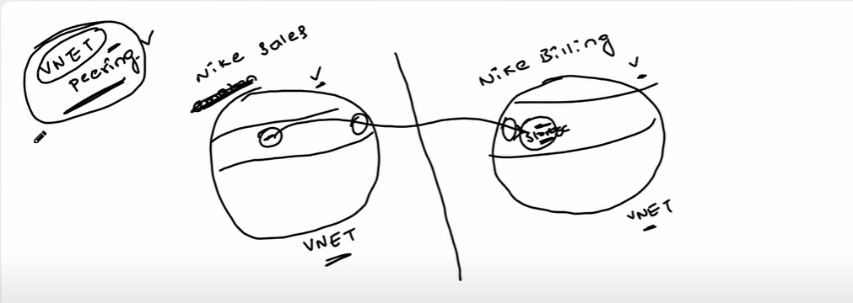

### VNet Gateway

VNet Gateway enables secure communication between on-premises networks and Azure Virtual Networks. Key features include:

* **Site-to-Site VPN**: Connects on-premises networks to Azure over an encrypted VPN tunnel.
* **Point-to-Site VPN**: Enables secure remote access to Azure resources.

## VPN Gateway

Azure VPN Gateway provides secure, site-to-site connectivity between your on-premises network and Azure. Key features include:

* **IPsec/IKE VPN Protocols**: Ensures secure communication over the Internet.
* **High Availability**: Supports active-active and active-passive configurations for high availability.
* **BGP Support**: Allows dynamic routing between your on-premises network and Azure.

Day 7 :-

# Azure Networking Demo | Azure VNet, Firewall, NSG and Bastion | Beginner Level Azure Project

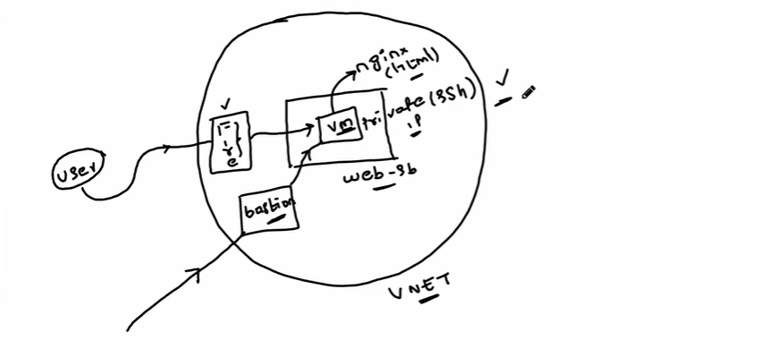

Step1:

Create a Azure resource group:

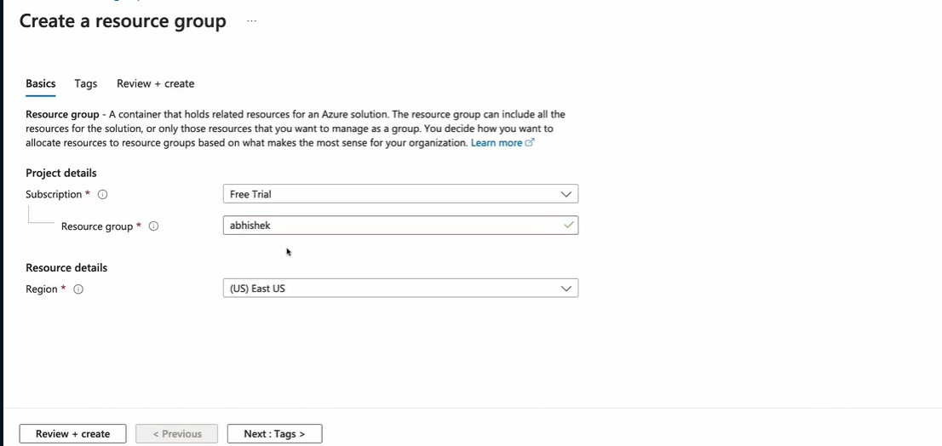

Step2:

Create a virtual network

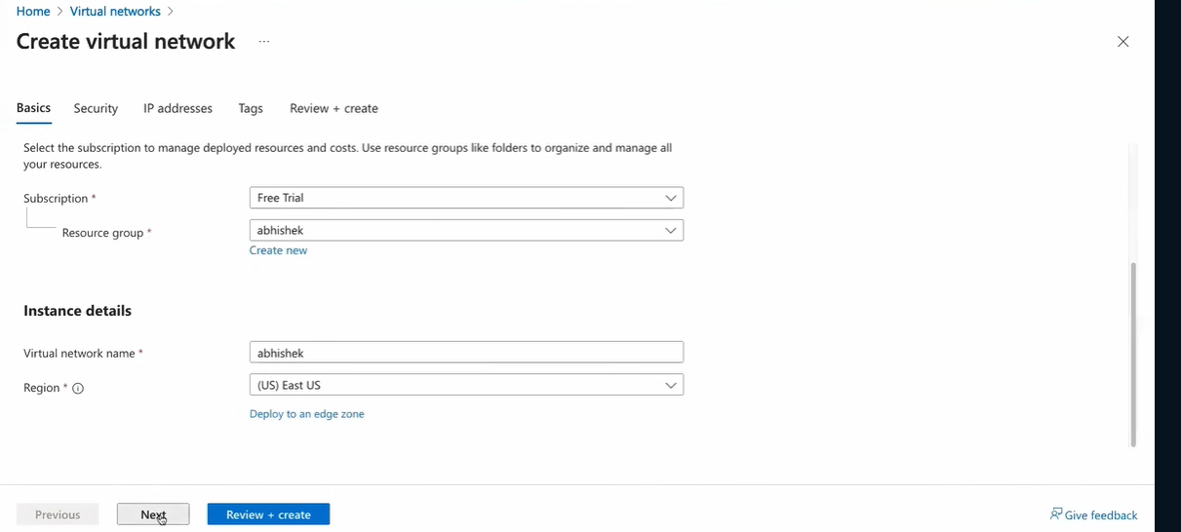

In security section

enable Azure bastion, and azure firewall

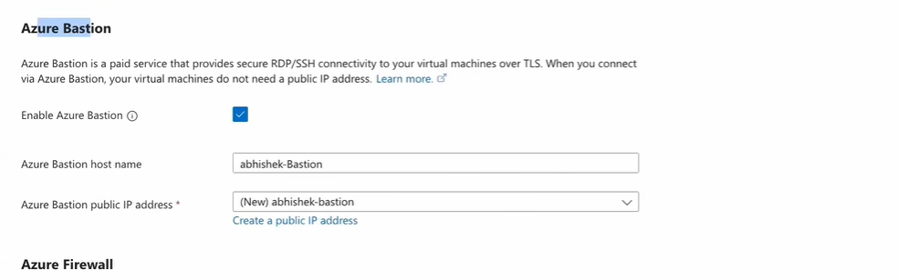

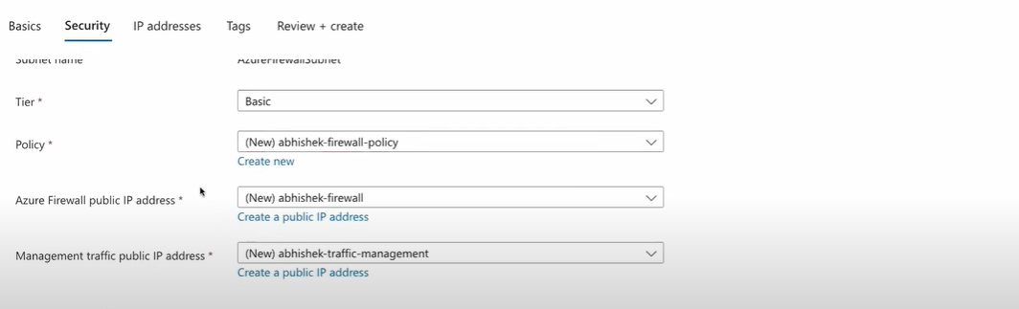

1 bastion can be used for n number of virtual machine.

Create a public IP address ( basic or standard level is perfect you can select as you wish)

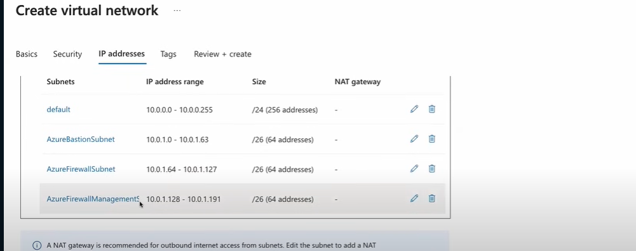

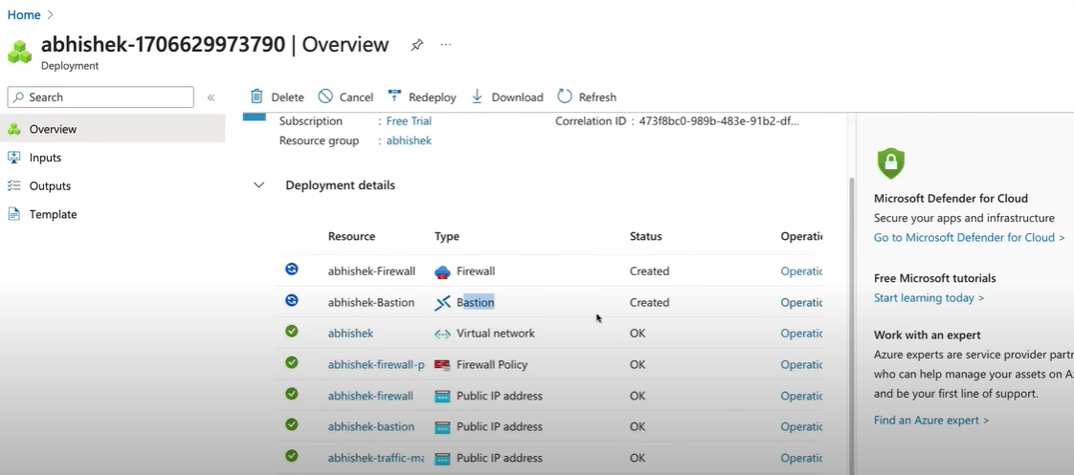

Step2:

Create a Virtual machine in the same resource group.

Same steps as we follow to create a virtual machine.

In networking section the subnet should be default and not under firewall management.

So we want our application behind Azure Firewall and we don’t want to expose it to the internet world.

